APPLICANT PACK

Senior Planner



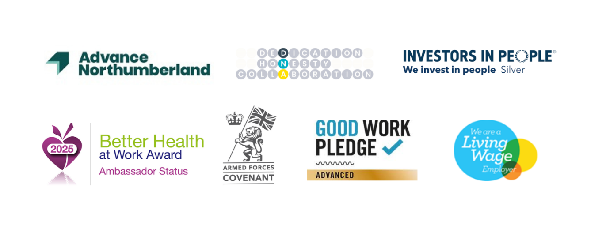

Who we are:
Advance Northumberland is a diverse property investment & development business, delivering opportunities to improve prosperity, tackle inequalities and drive economic growth in support of Northumberland County Council.

Whether its support for new and developing businesses, the remediation of challenging brownfield sites, building of large-scale manufacturing units, delivering new purpose-built offices, delivery of major town centre redevelopments, including complex retail developments, leisure facilities or the delivery of high-quality market sale and affordable housing it can all be found in this unique regeneration company.

We work collaboratively with stakeholders and partners, delivering positive physical and economic development. Focusing on the needs and aspirations of the county, addressing economic, housing and infrastructure challenges whilst capitalising on Northumberland’s significant assets and opportunities. We deliver a comprehensive regeneration capability to improve the County’s economic prosperity, regenerate communities, improve liveability and create a more connected and aspirational County.

In doing so, we will support a broader county-wide assets-based approach to promote economic growth and an improved quality of life for its communities. Building on the opportunities emerging from Northeast Combined Authority to enhance its regeneration impact, taking its lead from Northumberland County Council, and working in collaboration with key partners.

Advance Northumberland Projects, coordinate all of the groups Project activity through the Advance Northumberland Project Framework process.

The team also provide Project, Planning and Quality Management services to the rest of the group and deliver our own internal capital programme.

In addition, the team carry out work on behalf of Northumberland County Council to improve Northumberland for businesses and residents. Recent projects have included new award-winning leisure centres in Morpeth and Berwick; Regeneration of Blyth Town centre; Redevelopment of Bedlington town centre and Northumberland Energy Park

The land and planning team are now at the heart of our business continuing to secure the pipeline of land for Ascent Homes and now increasing their scope of activity to cover commercial, industrial and BNG land opportunities.

We are now seeking a Senior Planner to join the team as the business moves into an exciting period of growth as we deliver our new 5-year business plan.

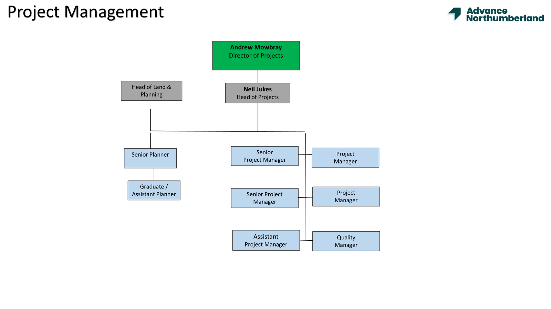

OUR VALUES
Our values are at the centre of our activities, linking to our vision to make Northumberland a wonderful place for people to live work and do business.

- Dedication – passionate and tenacious about delivering for Northumberland.
- Honesty – working to the highest standards of integrity and accountability.
- Collaboration – deliver in partnership with Northumberland County Council and organisations across the public and private sectors.

THE ROLE

Senior Planner
Salary range from £39,634 to £50,000 based on experience.
Reporting to the Head of Land and Planning, you will play a key role in the acquisition of land for residential, commercial and sustainability projects and securing planning permission for range of projects as we expand our development activities across multiple sectors.

How to apply
Please send your CV and a letter of application saying why you want to work for us and what you’d bring to the role, together with the completed application form Application Form.pdf to:

workforus@advancenorthumberland.co.uk
For an informal discussion, please contact: Andrew Mowbray, Director of Projects on 07966324361
Closing date for applications: 27th October 2025 at 10.00am,
Interviews will be held on 13th November 2025
We may close this role early if we receive sufficient applications.

If you wish to withdraw your consent for us to process your application, please email us at: workforus@advancenorthumberland.co.uk
- NO AGENCIES PLEASE
Thinking about a career at Advance Northumberland? Have a look at other vacancies we offer at https://www.advancenorthumberland.co.uk/careers
Advance Northumberland
Wansbeck Workspace
Rotary Parkway
Ashington
NE63 8QZ

Working for Advance Northumberland
We care about our colleagues and their wellbeing and have been nationally recognised for this. Apart from the competitive salary and performance related incentive scheme, we also have fantastic benefits. We focus on our colleague’s health, wealth, and lifestyle.





8% Employer Pension Contribution
Free Private Healthcare
Discounted Gym Membership
Up to 39 days Annual Leave






Salary Sacrifice NHS Car Fleet

Generous Occupational Sick Pay

- Additional Inf
Employee Assistance Programme

UK Healthcare
Cash Plan

Additional Information
Your annual leave will be 26 days, increasing to 31 days, after three years of employment. You can also buy up to 5 days additional annual leave per annum.
You are automatically enrolled into the Scottish Widows pension scheme, where you will pay a minimum of 2%, and we pay 8%, which totals to a 10% contribution effort.
Within the Employee Assistance Programme, you are eligible to receive 24/7 support, GP services, mental health support, dental and optical and other health therapies as well! You also gain access to our Cash Plan App, which includes discounts and cashback at various top retailers, and free on-site parking at all locations.
On the completion of your probation period, you will have the option to join our Private Healthcare scheme.
Hybrid Working – We offer the capacity to work on a hybrid basis, with three days in the office / on site. Of course, initially you might be in the office more, whilst you get to know your colleagues and our activities in more detail.

Job title: Senior Planner

Reports to: Head of Land and Planning
Team members: Graduate Planner
Location: Wansbeck Workspace and other locations as part of role.
Role Purpose: The Senior Development Planner is responsible for leading, coordinating, and delivering strategic and statutory planning functions for the Advance Northumberland Group. This role provides expert advice on planning strategy and execution on residential, commercial and sustainable development projects.

Duties and Responsibilities:

- Provide expert planning advise to the company, including scoping, project planning strategy and design

- Work on multiple projects which will be commensurate with the skill level, experience, and complexity of project issues to be addressed. To provide supervision of other projects within the planning function

- Preparation of appropriate applications and securing relevant approvals, consents and discharge of conditions in a timely manner.

- Work with project teams to develop the planning strategy and project design to best achieve viable planning success.
- Work with the Comms and Marketing teams to design and prepare and facilitate public consultation events

- Carry out research and report on development issues associated with the company’s business activities

- Undertake site surveys, record and report on observations and relate to planning policy, guidance, and issues.

- Assist in new site identification through analysis of opportunities and constraints, undertaking and commissioning research and feasibility.

- Liaise with planning authorities, key agencies and other consultees ensuring that their information requirements are met. Build relationships with key partners to ensure effective execution of role.
- Negotiate planning obligations, Section 106 agreements, and conditions with local authorities.

- Work closely with the wider business on all planning activities, to provide specific inputs into projects in terms of planning strategy, timescales programme viability and likely costs.

- Adhere to the Advance Northumberland Procurement Policy in the commission, procurement and management of consultants, working in planning, renewables, property, environmental and research areas e.g. planning lawyers, planners, highways consultants and environmental consultants. Manage, mentor and support the graduate / assistant planner ensuring the gain relevant experience and build confidence in the role
- Contribute to winning new business through networking, client presentations, and proposal writing.
- Support directors in developing new opportunities and expanding the client base.
- Maintain awareness of market trends, emerging planning policy, and development opportunities

Personal Specification

Essential Criteria

You must have:

- Educated to degree level or equivalent with qualifications in, or relevant to, Town and Country Planning

- Member of the RITP/RICS (or ready to work toward membership)

- Strong working knowledge of the England Planning system (NPPF, Local and Neighbourhood Plans)

- Excellent written and verbal communication skills

- Demonstrable experience of being able to work as part of a multi-disciplinary project team and on an individual basis

- Demonstrable experience of the ability to work to tight deadlines and under pressure

- Full UK Driving licence

It would be good but not essential if you also have:

- Experience of public speaking such as public consultation events and planning committees
- People management experience

