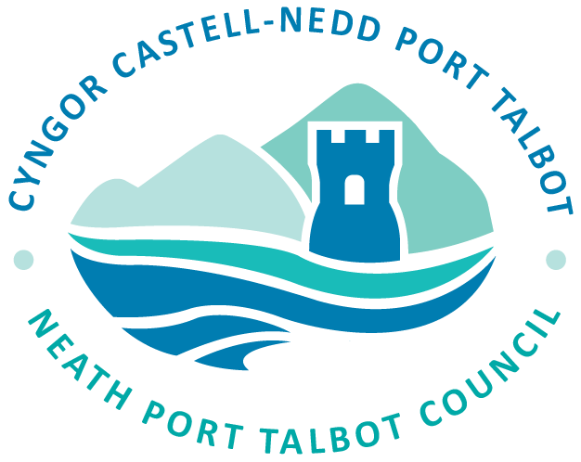

PERSON SPECIFICATION
Job title | Senior Policy Planner
Directorate | Environment & Regeneration
Section | Planning Policy (Local Development Plan) Team

Introduction
The purpose of this document is to enable you, as a candidate, to consider whether or not you have the attributes, which are required for appointment to this post. Please note that this document indicates those attributes that are considered to be essential to undertake the duties and responsibilities of this post and those that are merely desirable. If you do not possess any of the attributes that are desirable, this does not mean that you will not be considered for interview or subsequent appointment.

ATTRIBUTES |  | ESSENTIAL/  DESIRABLE | METHOD OF EVALUATION
Work experience | Experience in Planning Policy, including the development of evidence based strategy/policy making and monitoring for a range of topic/portfolio areas.  Experience of implementation of relevant legislation, regulations and national/regional policies.  Experience in delivering extensive public engagement and consultation programmes.  Experience of providing evidence at Examination in Public and Appeals. | Essential  Essential  Essential  Essential | Application form/Interview / Reference  Application form/Interview / Reference  Application form/Interview / Reference  Application form/Interview / Reference
Knowledge | Legislation, regulations and procedures in relation to Planning Policy.  Knowledge of the Planning System.  Knowledge of the Objective (U-Create/U-Engage) system.  Knowledge of the internal workings of the Local Authority. | Essential  Essential  Desirable  Desirable | Application form/Interview  Application form/Interview  Application form / Interview  Application form/Interview
Education and training | Planning qualification to RTPI standard or equivalent Planning Policy experience. | Essential | Application form/Interview
General skills/abilities | Ability to be proactive, to manage personal work portfolios and to coordinate / organise work priorities.  Ability to work under pressure and to deliver high quality work to agreed deadlines.  Ability to work either independently with minimum supervision or as part of a team supporting other team members.  Ability to be flexible and adaptable in carrying out a range of duties where priorities can change.  Good interpersonal and communication skills with the ability to deal with Members, colleagues, stakeholders, the public and landowners in a sensitive manner.  Good numeracy and literacy skills for report writing, record keeping, consultations and plans/strategies.  Ability to deal with a range of complex work and to identify / analyse potential problems and to develop and implement appropriate solutions.  IT literate with a range of IT systems / software. | Essential  Essential  Essential  Essential  Essential  Essential  Essential  Essential | Application form/Interview  Application form/Interview  Application form/Interview  Application Form/Interview  Application form/Interview  Application form/Interview  Application form/Interview  Application form/Interview
Other requirements | Have access to suitable transport. | Desirable | Application form/Interview
Welsh language | Welsh language skills are desirable.
DBS requirement | There is no requirement for a DBS check for this post.



